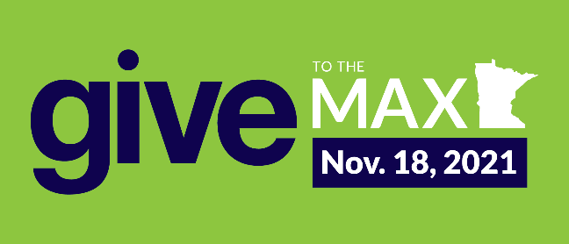
HOW TO HELP THE MINISTRIES FOUNDATION THIS GIVE TO THE MAX
Here’s How You Can Help:
- SOCIAL MEDIA: Share about Give to the Max on whichever social media platforms you use and/or re-share our GTMD posts. Please share multiple times! Make sure to include why you care about and support the Ministries Foundation, and the link to our GTM donation page: https://www.givemn.org/donate/Ministries-Foundation
  - Ministries Foundation GTMD page: https://www.givemn.org/organization/Ministries-Foundation/
  - Ministries Foundation Facebook: https://www.facebook.com/MinistriesFoundation
  - Ministries Foundation Twitter: https://twitter.com/MinistriesFndtn
  - Ministries Foundation Instagram: https://www.instagram.com/csjministriesfoundation/
- EMAIL: Forward an ask email or two to friends, family, co-workers and your other communities. Make sure you send something November 1 telling people that early giving for Give to the Max has begun and the link to donate: https://www.givemn.org/donate/Ministries-Foundation
  - Template email included below

- CREATE YOUR OWN FUNDRAISER: Set up your own giving page and share it with friends and family. This can easily be done by visiting our GTMD page; click the Fundraise button at the top of the page.

- DONATE ON NOVEMBER 18: Give to the Max Day is on Thursday, November 18 and monetary prizes are randomly awarded from GiveMN all day to participating organizations. Any donation over $5 enters the Ministries Foundation into the prize pool and goes toward our goal to raise $30,000.
A lot of people know about Give to the Max in Minnesota and it’s an easy way for people to donate/learn about who we are, what we do, and why it’s important. Thank you for telling your communities about the Ministries Foundation and for supporting us! Contact Alyssa Howells for any assistance at ahowells@csjministriesfoundation.org and/or 651-690-7061.
Frequently Asked Questions:
1. Do people have to donate through the GiveMN donation page on Give to the Max?
No, people do not have to donate on the GiveMN donation page. They are welcome to donate on the Ministries Foundation donate page (https://csjministriesfoundation.org/donate).
2. Doesn’t GiveMN charge a fee per donation?
Yes, GiveMN charges a fee per donation but over 90% of our donors choose to pay the fee. This has not been an issue in past years.
3. Do people have to donate on November 18 (Give to the Max Day)?
No, people do not need to donate on November 18 they can donate anytime between November 1 – 18 to have their donation count in the prize pool and Give to the Max totals. November 18 is when most people donate but people can donate at any time.

Template Email (fill in highlighted portions and copy & paste):
Option 1:
Hello,
This year Give to the Max Day in Minnesota is Thursday, November 18 and I hope you’ll join me in supporting the Sisters of St. Joseph Ministries Foundation. The Ministries Foundation responds to the needs of our communities through education, safe housing, healthcare, and spirituality. The programs it supports provide services to immigrants, refugees, women, men, children, families, and others living on the margins of society.
Through serving on the Board of Directors I’ve witnessed the positive impact of the Ministries Foundation and I believe that supporting its mission is vital, important, and needed now more than ever. I give to the Ministries Foundation because [insert reason, involvement, inspiring story, etc.].
Thank you for considering a donation to the Ministries Foundation during this year’s Give to the Max in support of social justice, healing, and hope. Please make a donation on its Give to the Max page at https://www.givemn.org/donate/Ministries-Foundation or donate directly on its website between November 1 - 18. Any gift, no matter the size, ensures that strong, vibrant communities will continue to thrive in the Twin Cities and beyond. It supports the individuals and families helping to build lasting, positive change.
Thank you for considering a donation to the Ministries Foundation during this year’s Give to the Max – it means a lot to them, and me.
Thank you,
[Name]
p.s. If you’re interested in knowing more about the Ministries Foundation consider signing up for its newsletter at https://csjministriesfoundation.org/subscribe/

Option 2:
Hello!
Give to the Max Day is Thursday, November 18 and I’ll be donating to the Sisters of St. Joseph Ministries Foundation - I’d love for you to join me. The Sisters of St. Joseph began providing healing and hope to those in need more than 170 years ago and will continue to provide healthcare, education, safe housing, and spirituality resources for many years to come. A donation to the Ministries Foundation, started to fundraise and additionally support the Sisters’ ministries, makes this all possible.
A donation to the Ministries Foundation teaches a father how to regulate his diet to avoid needing costly diabetes medications. It helps a mother learn the English she needs to apply for a job to support her family. It allows a woman to heal from trauma without worrying about her next meal, where she’ll sleep, or her physical safety. Your donation teaches a young woman how to advocate for social justice in her neighborhood, community, and for the rest of her life. It gives a neighbor the space to safely explore spiritual questions and theological insights.
A gift to the Sisters of St. Joseph Ministries Foundation is a gift that supports the individuals and families who make our communities strong, healthy, and vibrant. Look at its Give to the Max page or donate directly on its website, and please donate between November 1 - 18. Your contribution would mean so much to them, and me. All donations count toward their Give to the Max goal and special Give to the Max prizes. The Ministries Foundation could win up to $10,000 for its work with our help!
Thanks,
[Name]
p.s. Don’t forget to sign up for the Ministries Foundation newsletter to stay in the loop!

